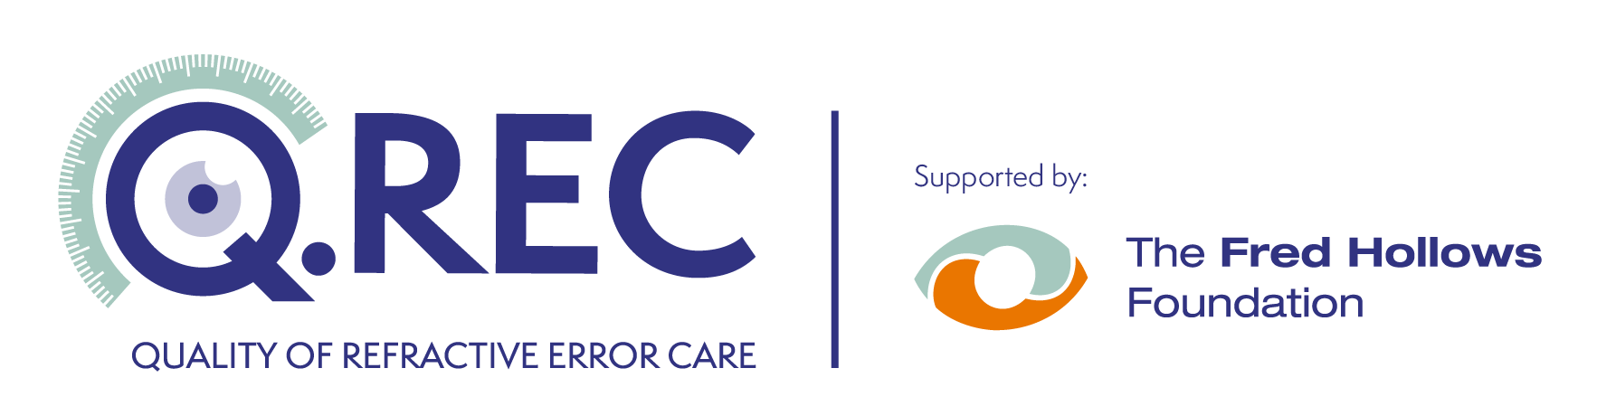

Quality of Refractive Error Care in REGION/COUNTRY

The Ministry of Health is working with researchers from PARTNER and ADDITIONAL PARTNERS to conduct a project about the quality of spectacles produced by optical services in REGION/COUNTRY.

We are looking for adults who need certain types of spectacles. We are also looking for adults who do not need spectacles to join our study. The study will be conducted between DATE RANGE.

The research study is looking to recruit people who meet the following criteria:
- Adults aged 18 years or above,
- Aduts with healthy eyes,
- Adults who have NOT had eye surgery in the past 3 months,
- Adults who have NOT had refractive eye surgery (LASIK),
- Adults who need certain types of spectacles OR adults who do not need spectacles.

You will be asked to participate in the following activities:
- Receive training to act as an unannounced standardized patient (3 days),
- Visit optical stores (up to 25) as an unannounced standardized patient where you would receive an eye examination and then complete a survey about the visit.
- Purchase spectacles (if recommended) and return them to the research team

You would receive the following reimbursement:
- If you are eligible, and decide to participate in this research, we will reimburse your travel, accommodation and some meal expenses during the course of the training.
- You would then be employed as part of the research and compensated for your time and effort at a rate of DOLLAR VALUE per day, for 10 to 20 days total.

If you would like to apply, or have questions about the research, please contact the following person by (date):

Name
Position
Telephone | +
Email

